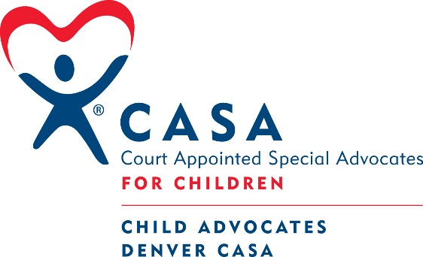

CHILD ADVOCATES - DENVER CASA

DIRECTOR OF DEVELOPMENT
JOB DESCRIPTION

Reports to: Executive Director
Exempt, Full time position

Child Advocates - Denver CASA’s mission is to recruit and train community volunteers from diverse backgrounds to advocate for the best interests of children, who have experienced abuse or neglect, in the pursuit of safe and permanent homes. We are looking for someone with experience in development who can expand a diverse and sustainable resource development program, including annual giving, major donors, corporate partnerships and events to increase the budget and support growth of the organization.

Diversity, Equity, Inclusion and Belonging:

Denver CASA continues to build a diverse and inclusive culture that encourages, supports, and celebrates the distinct voices of our employees, volunteers, board members and children served. We want every employee to feel valued and appreciated and bring their full authentic selves to work. Denver CASA does not discriminate on the basis of basis of race, color, religion (creed), gender, gender expression, age, national origin (ancestry), disability, marital status, sexual orientation, or military status, in any of its activities or operations

Employees are currently working remotely with only scheduled time in the office until further notice. The majority of training will be remote.

Job Description:
- Develop and implement a strategic development plan along with the Board and Executive Director that includes individual donors, foundations and corporations.
- Drive revenue development to increase the overall organizational budget to support growth under new strategic plan.
- Lead and support the Board Development Committee to assist with achieving organizational revenue goals.
- Supervise Community and Corporate Engagement Manager and their efforts in outreach and recruitment of volunteers, corporate connections and general community support.
- Oversee all marketing efforts, including general and donor-specific communication via newsletters, social media, press releases, event promotions, development of collateral, etc.
- Work in concert with the program staff to deliver clear and compelling content to donors, supporters and potential supporters.
- Develop and implement a major gift program, including research, identification and developing the case for giving.
- Maintain a portfolio of individual donors and corporate partners to cultivate, solicit and steward.
- Oversee annual giving campaign. Manage the donor database software, working with the Operations Director to ensure proper data entry, acknowledgements and reporting.
- Furnish timelines, presentation materials, training and other support as needed to the Executive Director and Board for fundraising purposes.
- Provide professional expertise and direction to staff and Board of Directors on all aspects of fundraising.
- Participates on leadership team by establishing organizational, and fundraising strategies, policies, procedures, plans, goals and budget.
- Track effectiveness of development efforts and report on KPIs.
- Collaborate with development teams from other statewide CASA programs to identify prospective donors and corporate partners.

REQUIREMENTS/QUALIFICATIONS:
- Strong commitment to Child Advocates – Denver CASA’s mission and the children and families we serve.
- Bachelor’s degree or equivalent work experience.
- At least 3-5 years of experience in fundraising with a track record of creating strategic fundraising plans and meeting or exceeding revenue targets.
- Proven experience in prospecting, soliciting and stewarding individual major gifts and corporate partnerships.
- Proven experience with social media, e-news platforms, mail house procedures and other tools to promote fundraising and marketing campaigns.
- Excellent leadership, management and decision-making skills.
- Proven experience planning successful in-person, hybrid and virtual events.
- Proven record of increasing revenue year over year from diversified funding sources.
- Comfort working with Denver community and people from diverse backgrounds; ability to network and advance mission of Denver CASA.
- Ability to work to deadlines and prioritize workloads. Ability to take initiative in completing assigned projects with minimal supervision.
- Excellent verbal and written communication skills, including copy writing and correspondence.
- High level of competence with technology and experience managing donor software.
- Ability to work from home.
- Must be available for flexible day, evening and week-end work hours.
- Enjoys collaboration and working as a team.

Salary Range: $60,000 - $70,000 depending on experience
We offer a comprehensive benefits package including health, dental, short term disability and life insurance, a retirement plan and generous paid time off.

To apply: Send a cover letter and resume in one pdf to admin@denvercasa.org

